GIS Application

NCGSA Internship – week 1

18/7/22 | IST NAV App development | Mam Aneeqa

Kiran Sardar | 200901064

Syeda Farwa Rizvi | 200901098

# Literature Review

In the 1st week, we worked on creating the tasks as instructed for new internees as well as setting up react native environment, which requires setting up VS code, Yarn, Git, Node.js, and Expo CLI.

## Tasks Assigned for new internees

4 tasks were defined with references and guidance on how tasks are to be completed for new interested internees.

## Environment setup

#### React Native

The development of the IST NAV app was decided to be done on React Native. This is to create native applications that don't degrade your users' experience using React Native. Core native components such as View, Text, and Image are provided that map immediately to the native UI building elements of the platform.

#### Expo CLI – Expo Go

i) Basic Layout

Expo Command Line Interface, and is the main interface between the developer and Expo's underlying frameworks and services. There are a variety of things you can do with it over the course of your project's development life cycle. These include providing support for your work in progress, examining logs, running the app on an emulator or actual device, and so on.

Requirements:

1. [Node.js LTS release](https://nodejs.org/en/)
2. [Git](https://git-scm.com/)
3. [Watchman](https://facebook.github.io/watchman/docs/install#buildinstall); only for macOS or Linux users
4. Download Expo Go on a mobile device as an emulator

Tools:

1. [VS Code Editor](https://code.visualstudio.com/download)
2. [VS Code Expo Extension](https://marketplace.visualstudio.com/items?itemName=byCedric.vscode-expo) for **app.json** debugging and autocomplete
3. [Yarn](https://classic.yarnpkg.com/en/docs/install)
4. Windows users: [PowerShell](https://docs.microsoft.com/en-us/powershell/scripting/install/installing-powershell-core-on-windows), Bash via WSL, or the VS Code terminal

### Documentation

1. <https://reactnative.dev/docs/environment-setup>
2. <https://docs.expo.dev/get-started/installation/>

## to create a new project

1. Create a new folder with the name proj_name
2. Open the folder in the VS Code editor
3. Go to terminal-> new terminal
4. Run the following commands:

npm install yarn --global

yarn global add expo-cli

expo init poj_name

expo whoami

expo login (if necessary)

npm install -g yarn

## to open a project

In new terminal run:

cd proj_name

yarn start

ii) Code chart

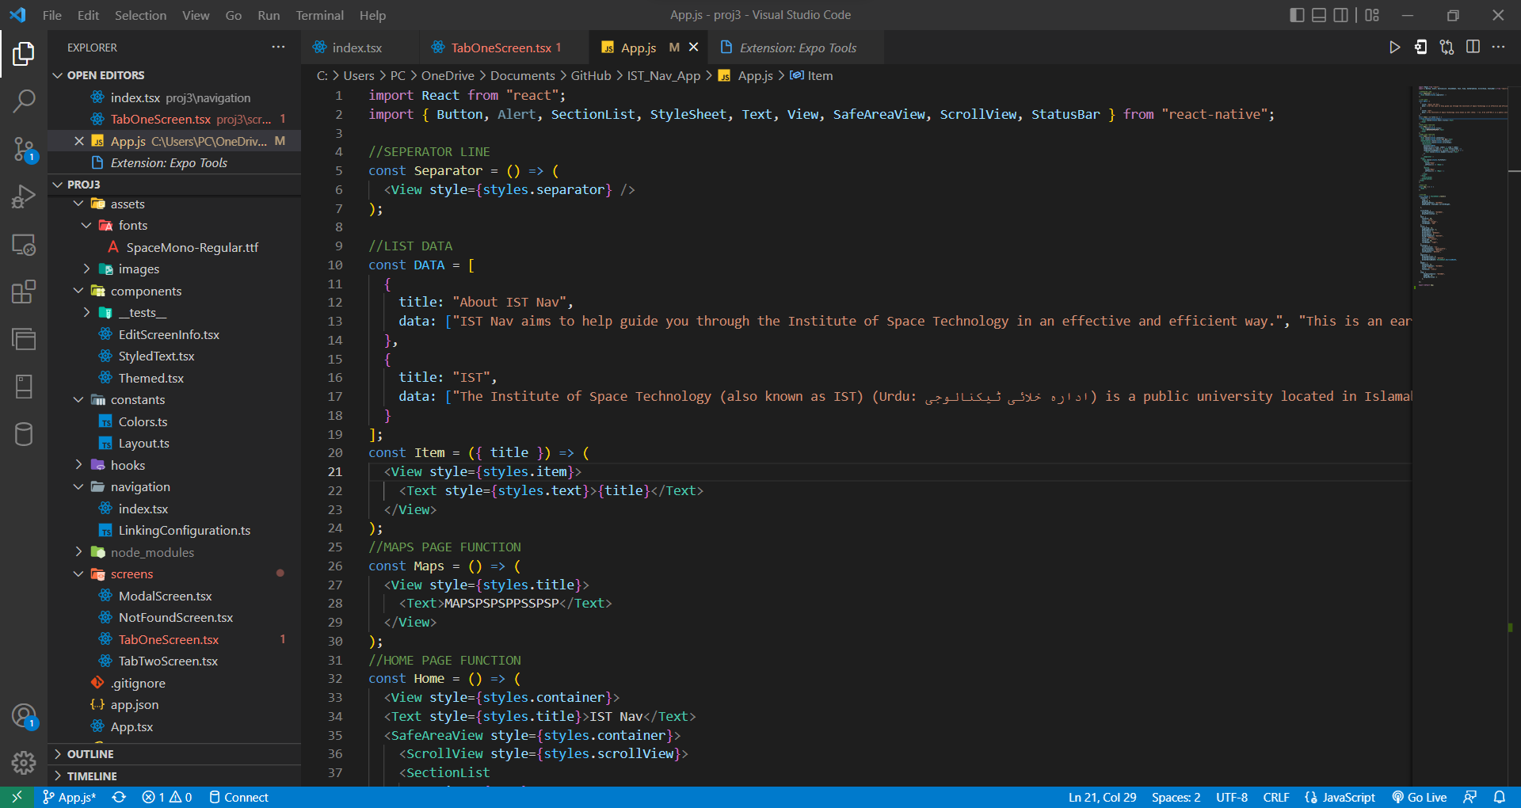

iii)coding spcae created